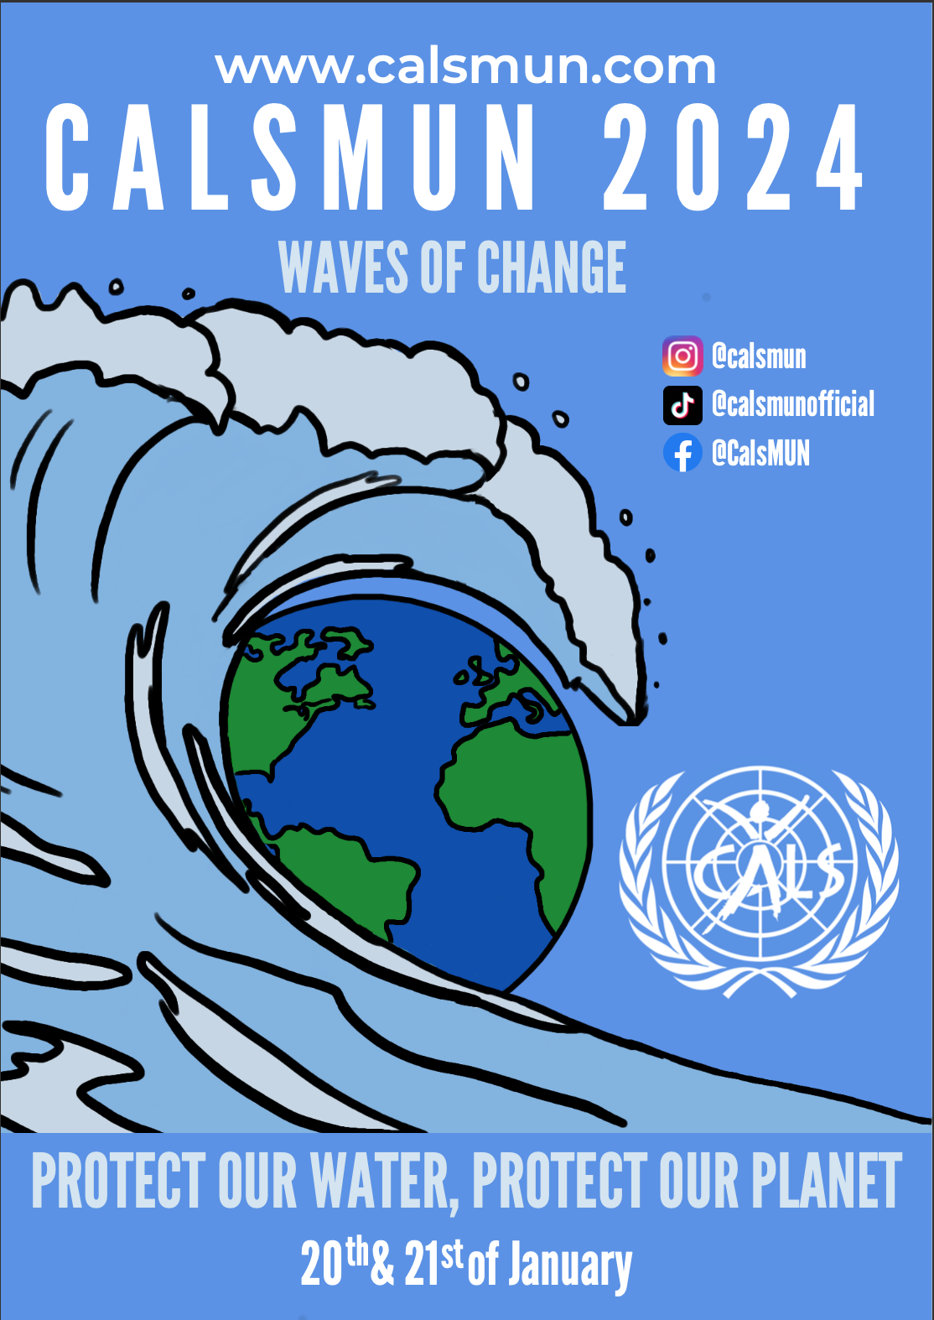
Waves of Change CalsMUN 2024

Research Report
Forum: General assembly 1
Issue: Enhancing Ocean Governance and Strengthening International Legal Frameworks to Address Maritime Disputes
Chairs: Medea Beridze, Vincent Esser and Oliver McCafferty

Introduction
The large oceans that make up more than 70% of the planet's surface have long been a source of wealth and a point of conflict for nations. The topic of improving ocean governance and strengthening international legal frameworks to resolve maritime conflicts has become more and more prominent in international discourse in recent years. The oceans hold importance not only for international trade and transportation, but also for maintaining biodiversity and controlling Earth's climate. Maritime disputes which are arising from competing territory claims, competition for resources, environmental deterioration, and geopolitical rivalries, provide large obstacles to global stability. Effective ocean management and governance are becoming more and more important as trade, technology, and environmental interdependence make the world a more interconnected place. There is also a strong competition among nations to claim their share of the resources due to resource exploitation, such as minerals, oil, and gas found in the ocean. This explores possible approaches and solutions to improve ocean governance and fortify the international legal frameworks that regulate marine operations in order to navigate these problems.
Definition of Key Terms:
Maritime disputes

Maritime disputes are essentially conflicts or confrontations involving the seas and oceans between two or more countries. Often they are conflicting claims over maritime borders, territorial waters, exclusive economic zones, or the usage and management of shared marine resources.

Legal Frameworks

Legal frameworks are collections of established rules and laws that offer an orderly way to handle legal matters in a specific field. Legal frameworks set forth regulations and standards for the use, management, and settlement of conflicts pertaining to the world's oceans in the context of maritime affairs.

Exclusive economic zones (EEZs)

An "exclusive economic zone," or "EEZ," is a region of the ocean where a coastal nation has control over both living and nonliving resources. It typically extends 200 nautical miles (230 miles) beyond the nation's territorial sea. The coastal state is entitled to full rights over natural resources, such as fisheries, oil, and gas exploration, within the EEZ.

United Nations Convention on the Law of the Sea (UNCLOS)

The UNCLOS (The United Nations Convention on the Law of the Sea) is a comprehensive legal framework governing the use and management of the world's oceans and seas. Maritime boundaries, exclusive economic zones, navigation, environmental protection, scientific research, and the settlement of maritime disputes are among the rights and obligations that are outlined in this convention, which was enforced in 1994.

Marine Protected Areas

Marine Protected Areas (MPAs) are designated areas within the ocean where human activity is prohibited to preserve and safeguard the ecosystems, biodiversity, natural resources and habitats. These places can protect important habitats, hold onto endangered species, and support sustainable fishing, among other things. The general resilience and well-being of maritime habitats are enhanced by MPAs.
General Overview
At its foundation, maritime disputes are conflicts and disagreements resulting from competing claims and interests in the world's oceans. These debates, issues and conflicts arise from a wide range of topics, including resource extraction, resource utilisation, exclusive economic zones (EEZs), territorial boundaries, fishing rights, sovereignty of ocean, etc. The South China Sea, where countries fight for control over vital waterways and resource-rich areas, and the Arctic region, where melting ice creates new opportunities and difficulties, are two prominent examples of a maritime dispute. Due to the complexity of these issues, a comprehensive approach that takes into account the legal, diplomatic, and environmental aspects is required. There have been attempts to solve the issues at hand, however they are mostly disregarded or not seen as prominent solutions.
There are many obstacles and large issues in the way of improving ocean governance and fortifying international legal frameworks. Effective dispute resolution is hampered by geopolitical rivalries, divergent interpretations of maritime law, and a lack of enforcement measures, as stated above. The spirit of collaborative governance may be undermined by certain countries' selective adherence to international agreements based on their perceived national interests, one example being the UNCLOS. However, regardless of these difficulties, there are chances for creativity and teamwork. Technological developments like data analytics and satellite tracking provide new instruments for law enforcement and surveillance, and luckily enough, are likely to be strong enough to be a legitimate solution to our issues. Resolution of longstanding issues is facilitated by diplomatic activities that promote conversation. Atlast, geopolitics, environmental diplomacy, and commercial interests all deeply play a large role on "the question of enhancing ocean governance and strengthening international legal frameworks to address maritime disputes.". Although It will take a team effort to resolve these complicated problems by promoting sustainable practices, diplomatic communication, and the rule of law, it will be a worthwhile effort in the long run for state sovereignty. Cooperation becomes an important aspect for ensuring a future in which the oceans continue to be a shared resource, essential to the wealth and well-being of the global community, as nations negotiate the complex difficulties of maritime concerns.

Major Parties Involved
International organisations
International organisations are vital. Examples include the United Nations (UN) and its specialised agencies, the International Maritime Organization (IMO) and the International Tribunal for the Law of the Sea (ITLOS). Imagine them as the international forums where countries convene to discuss, debate, and reach consensus over maritime regulations. Similar to how the United Nations serves as the global diplomatic living room, the ITLOS and IMO are the primary forums for resolving legal disputes and developing shared guidelines for the usage, navigation, and commerce of the oceans. These organisations encourage cooperation and a sense of shared accountability for our large and complicated maritime home. They serve as a glue, binding our worldwide ocean community together.
Countries with maritime claims
Directly involved are nations that have maritime claims, such as those in the South China Sea or the Arctic region. Due to competing territorial and economic interests, they must actively participate in court cases, regional agreements, and negotiation procedures in order to resolve conflicts and guarantee the appropriate use of marine resources. Each of these nations want their share of rights regarding the ocean and the resources that come with the ocean, however it is vital that these rights are spread among nations evenly.
Coastal states
Coastal states have direct correlation with ocean governance. They are in charge of maintaining, managing and protecting exclusive economic zones (EEZs), protecting maritime borders, and settling conflicts which confine and agree with international law. In order to help coastal communities, they are interested in encouraging sustainable practices, safeguarding marine security, and protecting natural resources. These states have the responsibility to keep the ocean protected.
Regional organisations
Within particular geographic areas, regional organisations such as the European Union or ASEAN play a crucial role in handling maritime challenges. They support regional collaboration, communication, and the creation of agreements for the efficient management and resolution of conflicts, taking into account the particular difficulties and dynamics of the regions in which they operate. This is crucial, and these regional organisations oversee specific areas instead of on a global level. This means that it is easier for specific areas to be managed.
Possible Solutions
There are a number of possible solutions to the deep rooted issue. These solutions are mostly reasonable ways to tackle the issue whilst overseeing a diplomatic, legal and cooperative point of view. Firstly, there must be diplomatic communication and negotiation among nations in order to peacefully resolve the issues related to the topic. Nations can undergo peace talks to discuss their place regarding the issues, and they should also be deeply encouraged to do so. This will lead to minimal conflict which can result in less violence, less tension, and a sufficient way to solve the problems surrounding the issue.

Additionally, the United Nations has created a convention on the Law of the Sea (UNCLOS), which was opened for signature on the 10th of December 1982, and was entered into force on 16th of November 1994. The constitution establishes a legal framework which essentially manages and governs the world's oceans and seas. This convention addresses its maritime affairs, territorial sea limits, exclusive economic zones (EEZs) and environmental protection. Unfortunately, some nations may selectively adhere to the rules of UNCLOS based on their national interests. For the convention to be effective and beneficial, there needs to be consistency in the adherence of the convention. There should also be efforts made for non participating nations to join and embrace the convention. In order for this to happen, there could be incentives to encourage nations to comply with the provisions of UNCLOS. Additionally, there could be awareness raised on the importance of promoting international cooperation and resolving maritime disputes, which could encourage nations to adhere to the laws of international waters, and end conflicts. Public awareness could also influence governments and nations to adhere to the laws as a public opinion could lead to protests or other ways which could allow the nation to adhere to UNCLOS.

There could also be global collaboration encouraged for the sustainable management of maritime resources, which would guarantee equal access to resources for every nation. This would ease tension and limit conflict over resources such as fish stocks, minerals, gas, etc. Along with this, the implementation of measures to protect the ocean from illegal fishing, regulating pollution, and general promotion of sustainability would be beneficial. This would also regard the effective management of Marine Protected Areas in order to preserve biodiversity, promote sustainable fishing and safeguard the critical marine environments.

Bibliography

“General Assembly Adopts Two Resolutions on Oceans, Highlighting Mounting Threats to
Marine Resources, Need to Tackle Rising Sea Levels, Damage to Ecosystems | UN
Press.” Press.un.org, press.un.org/en/2023/ga12569.doc.htm.

NOAA Ocean Exploration. “What Is the “EEZ”?: Exploration Facts: NOAA Office of Ocean
Exploration and Research.” Oceanexplorer.noaa.gov,
oceanexplorer.noaa.gov/facts/useez.html#:~:text=An%20%E2%80%9Cexclusive%20
economic%20zone%2C%E2%80%9D. Accessed 17 Dec. 2023.

“Strengthening the International Ocean Governance Framework.”
Oceans-And-Fisheries.ec.europa.eu, 20 Sept. 2023,
oceans-and-fisheries.ec.europa.eu/ocean/international-ocean-governance/strengthenin
g-international-ocean-governance-framework_en.

“The World Bank: Strengthening Capacity on Ocean Governance.” World Bank,
www.worldbank.org/en/topic/environment/brief/strengthening-capacity-on-ocean-gov
ernance.

United Nations. “Overview - Convention & Related Agreements.” Un.org, 2012,
www.un.org/Depts/los/convention_agreements/convention_overview_convention.htm
.

Young, Margaret A. “Strengthening Capacity in Ocean Governance.” Asia-Pacific Journal of
Ocean Law and Policy, vol. 8, no. 1, 16 June 2023, pp. 5–24,
https://doi.org/10.1163/24519391-08010002. Accessed 26 Sept. 2023.

Europa.eu, 2022,
eur-lex.europa.eu/legal-content/EN/TXT/HTML/?uri=CELEX:52022JC0028.
Accessed 26 Dec. 2023.

